PAPER TITLE

These instructions give you guidelines for preparing an academic papers for the 34th World Congress. Use this document as an instruction set.

Title:
The title of the paper should be concise and informative. Avoid abbreviations and formula if possible.

Abstract
The abstract contains between 150 and 200 words, outlining the purpose, scope and conclusions of the paper.

Keywords: Between 3-5 keywords in alphabetical order, separated by commas. Each keyword should not contain more than two compound words, and each keyword phrase should start with an uppercase letter. Keywords should express the precise content of the paper as they are used for indexing purposes.

- Paper structure

1.1 Introduction
State the research problem, the objectives of the paper, and provide an adequate background.

1.2 Methodology
The paper should reflect the methodology used.

1.3 Findings
Findings should be clear and concise, and emphasize the contribution of the paper.

1.4 Discussion and conclusion
This section should explore the significance of the research results, not repeat them, and present the final remarks.

- Formatting

Authors should submit their papers in English. Submission of a paper implies that it has not been published previously, that it is not under consideration for publication elsewhere, in English or any other language. Full paper should contain between 4,000 and 7,000 words (excluding bibliography).

  - Headings
The paper is organized in sections, sub-sections, sub-sub-sections. Headings are numbered using the decimal system (1, 1.1 and 1.1.1). Only the first three headings’ levels are numbered. Use the default styles in Word to identify the heading levels. Headings are formatted in bold or italics. They have no end punctuation or period after heading number.

  - Paper Body
Use the standard Word functions for displayed lists, type styles such as bold or italics, the indexing function, and the footnote function. Use a single main font for the entire text. We recommend Times New Roman (font size 12, double line spacing). For special characters, please use Symbol and/or Arial Unicode. Footnotes are always place at the bottom of the page (not at the end of the chapter). The reason for including footnotes is to provide additional information, but they should never include the bibliographic details of a reference. Reference citations are given with numbers in brackets.

  - Figures and Tables
Authors must provide high-quality artwork for all figures. Figure captions begin with the term Fig. in bold type, followed by the figure number, also in bold type. Figure captions have no end punctuation and no period after the figure number. If excerpts from copyrighted works (including websites) such as illustrations, tables, animations, or text quotations are included in your manuscript, please obtain permission from the copyright holder (usually the original publisher) for both the print and online format.

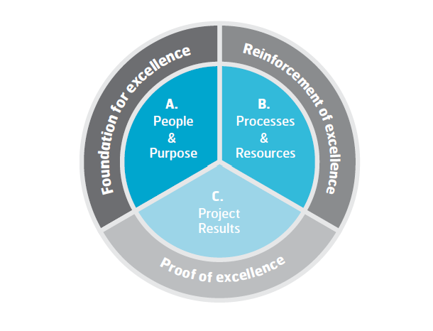
Fig. 1 Project Excellence Model (IPMA, 2016)

Table captions should be typed into the manuscript, directly above the table. Captions are to be listed in numerical order, labeled as “Table 1”, “Table 2”, etc.

Table 2 Prefixes
Prefix | Meaning | Abbreviation
kilo- | Thousands | k
centi- | Hundredths | c
milli- | Thousandths | m
micro- | Millionths | μ

Figures and tables should be referred in the main text using Fig. 1, or Table 1.

  - Equations
Use the Math function, MathType, or Microsoft Equation Editor to create your equations. Please don’t include the equations as images. Equations should be numbered consecutively with bracketed Arabic numerals in the right-hand margin. Careful attention must be paid to sub- and superscript symbols, and upper- and lower-case letters. Be sure that the symbols in your equation have been defined before the equation appears or immediately following. Italicize symbols used in paragraphs. Refer to Eq. 1 not “Equation (1),” except at the beginning of a sentence: “Equation (1) is ....”

  - Reference System
All sources and references should be acknowledged using the Harvard referencing system. References should be limited to pertinent works or papers that have been published or accepted for publication in journals covered by major scientific databases. Avoid extensive lists of references that use excessive words and space on the printed page. Usually, this can be achieved with fewer than 30 references. All listed references must be cited in the text. The list of references should be alphabetically by the last name of the first author (example: Bushuyev & Wagner, 2014; Pinto, 2014) and numbered serially. The names of all authors should be listed. References by the same author or group of authors should be listed in chronological order.

References
Bushuyev, S. D., & Wagner, R. F. (2014). IPMA Delta and IPMA Organisational Competence Baseline (OCB): New approaches in the field of project management maturity. International Journal of Managing Projects in Business, 7(2), 302-310.
Pinto, J. K. (2014). Project management, governance, and the normalization of deviance. International journal of project management, 32(3), 376-387.
Hedeman B., Riepma R. (2023). Project Management by ICB4. IPMA/Van Haren Publishing

  - Acknowledgment (if applicable)
Use the singular heading even if you have many acknowledgments. The acknowledgments header is not numbered. The names of funding organizations should be written in full.

